LOAN ANALYSIS |QUERY DOCUMENT|

1.Total no. of Loan Application

Select COUNT(id) AS Total_Loan_application FROM Bank_data

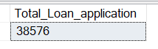

2.Month-to-date Total Loan Application

Select COUNT(id) AS MTD_Total_Loan_application FROM Bank_data

WHERE MONTH(issue_date) = 12 AND YEAR(issue_date) = 2021



3. Previous Month-to-Date total Loan Application

Select COUNT(id) AS PMTD_Total_Loan_application FROM Bank_data

WHERE MONTH(issue_date) = 11 AND YEAR(issue_date) = 2021



4.Total Funded Amount

Select SUM(loan_amount) AS Total_Funded_Amount FROM Bank_data



5.Month-to-Date Total Funded Amount

Select SUM(loan_amount) AS MTD_Total_Funded_Amount FROM Bank_data

WHERE MONTH(issue_date) = 12 AND YEAR(issue_date) = 2021



6.Previous Month-to-Date Total Funded Amount

Select SUM(loan_amount) AS PMTD_Total_Funded_Amount FROM Bank_data

WHERE MONTH(issue_date) = 11 AND YEAR(issue_date) = 2021



7.Total Amount Received

Select SUM(total_payment) AS Total_Amount_Recieved FROM Bank_data



8.Month-to-Date Total Amount Received

Select SUM(total_payment) AS MTD_Total_Amount_Recieved FROM Bank_data

WHERE MONTH(issue_date) = 12 AND YEAR(issue_date) = 2021



9.Previous Month-to-Date Total Amount Received

Select SUM(total_payment) AS PMTD_Total_Amount_Recieved FROM Bank_data

WHERE MONTH(issue_date) = 11 AND YEAR(issue_date) = 2021



10.Average Interest Rate

Select ROUND(AVG(int_rate),4)*100 AS Average_Interest_Rate FROM Bank_data



11.Month-to-Date Average Interest Rate

Select ROUND(AVG(int_rate),4)*100 AS MTD_Average_Interest_Rate FROM Bank_data

WHERE MONTH(issue_date) = 12 AND YEAR(issue_date) = 2021



11.Previous Month-to-Date Average Interest Rate

Select ROUND(AVG(int_rate),4)*100 AS PMTD_Average_Interest_Rate FROM Bank_data

WHERE MONTH(issue_date) = 11 AND YEAR(issue_date) = 2021



12.Average Debt-to-Income Ratio

Select ROUND(AVG(dti),4)*100 AS Average_DTI_Ratio FROM Bank_data

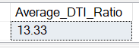

13.Month-to-Date Average Debt-to-Income Ratio

Select ROUND(AVG(dti),4)*100 AS MTD_Average_DTI_Ratio FROM Bank_data

WHERE MONTH(issue_date) = 12 AND YEAR(issue_date) = 2021



14.Previous Month-to-Date Average Debt-to-Income Ratio

Select ROUND(AVG(dti),4)*100 AS PMTD_Average_DTI_Ratio FROM Bank_data

WHERE MONTH(issue_date) = 11 AND YEAR(issue_date) = 2021



15.Good Loan Application Percentage

SELECT

(COUNT(CASE WHEN loan_status='Fully Paid' OR loan_status='Current' Then id END)*100)

/

COUNT(id) AS Good_Loan_Application_Percentage

FROM bank_data



16.Good Loan Application

SELECT COUNT(CASE WHEN loan_status='Fully Paid' OR loan_status='Current' Then id END) AS Good_Loan_Application

FROM bank_data

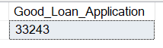

17.Good Loan Funded Amount

SELECT SUM(loan_amount) AS Good_Loan_Funded_Amount FROM bank_data

WHERE loan_status='Fully Paid' OR loan_status='Current'

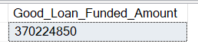

18.Good Loan Total Received Amount

SELECT SUM(total_payment) AS Good_Loan_Total_Recieved_Amount FROM bank_data

WHERE loan_status='Fully Paid' OR loan_status='Current'

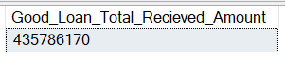

19.Bad Loan Application Percentage

Select

(COUNT(CASE WHEN loan_status ='Charged Off' THEN id END)*100.0)

/

COUNT(id) AS Bad_Loan_Application_Percentage

FROM bank_data

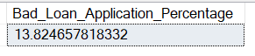

20.Bad Loan Application

SELECT COUNT(id) AS Bad_Loan_Application FROM Bank_data

WHERE loan_status ='Charged Off'



21.Bad Loan Funded Amount

SELECT SUM(loan_amount) AS Bad_Loan_Funded_Amount FROM Bank_data

WHERE loan_status ='Charged Off'

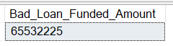

22.Bad Loan Total Received Amount

SELECT SUM(total_payment) AS Bad_Loan_Total_Recieved_Amount FROM Bank_data

WHERE loan_status ='Charged Off'



23.Loan Status

SELECT

loan_status,

COUNT(id) AS Total_Loan_Application,

SUM(loan_amount) AS Total_Funded_Amount,

SUM(total_payment) AS Total_Recieved_Amount,

AVG(int_rate*100) AS Average_Interest_Rate,

AVG(dti*100) AS Average_DTI

FROM Bank_data GROUP BY loan_status

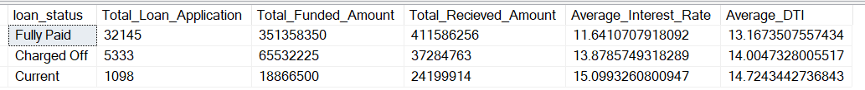

SElECT loan_status,

SUM(loan_amount) AS MTD_Total_Funded_Amount,

SUM(total_payment) AS MTD_Total_Amount_Recieved

FROM Bank_data

WHERE

MONTH(issue_date) = 12 AND YEAR(issue_date) = 2021

GROUP BY

loan_status

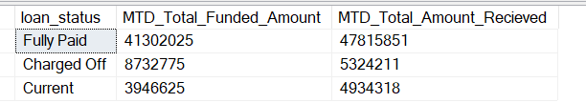

24.Monthly Trend By Issue Date

SELECT

MONTH(issue_date) AS month_number,

DATENAME(MONTH,issue_date) AS month_name,

COUNT(id) AS Total_Loan_Application,

SUM(loan_amount) AS Total_Funded_Amount,

SUM(total_payment) AS Total_Recieved_Amount

FROM Bank_data

GROUP BY MONTH(issue_date) , DATENAME(MONTH,issue_date)

ORDER BY MONTH(issue_date)

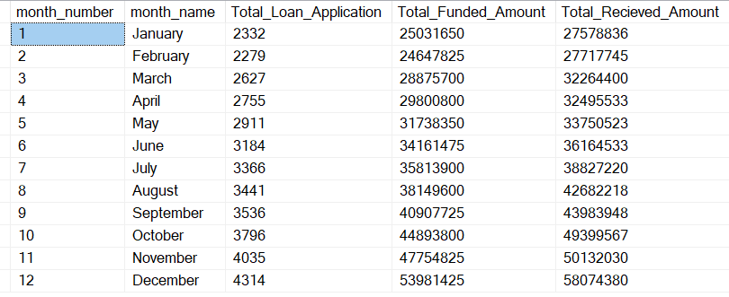

25.Regional Analysis By State

SELECT

address_state,

COUNT(id) AS Total_Loan_Application,

SUM(loan_amount) AS Total_Funded_Amount,

SUM(total_payment) AS Total_Recieved_Amount

FROM Bank_data

GROUP BY address_state

ORDER BY COUNT(id) DESC

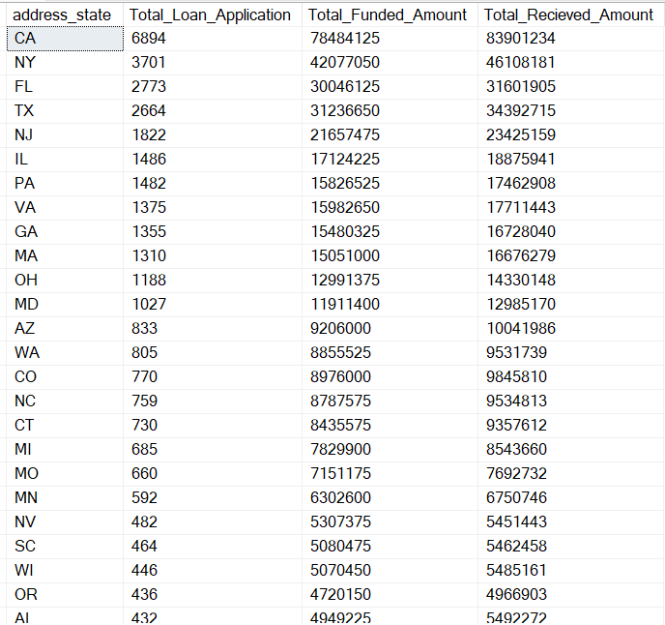

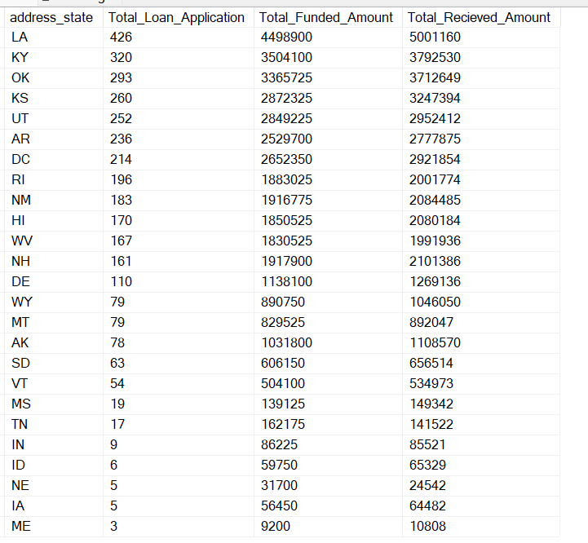

26.Loan Term Analysis

SELECT

term,

COUNT(id) AS Total_Loan_Application,

SUM(loan_amount) AS Total_Funded_Amount,

SUM(total_payment) AS Total_Recieved_Amount

FROM Bank_data

GROUP BY term

ORDER BY COUNT(id) DESC

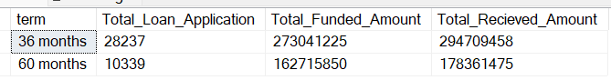

27.Employee Length Analysis

SELECT

emp_length,

COUNT(id) AS Total_Loan_Application,

SUM(loan_amount) AS Total_Funded_Amount,

SUM(total_payment) AS Total_Recieved_Amount

FROM Bank_data

GROUP BY emp_length

ORDER BY emp_length

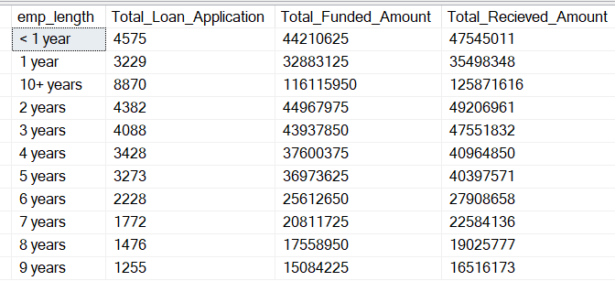

28.Loan Purpose Breakdown

SELECT

purpose,

COUNT(id) AS Total_Loan_Application,

SUM(loan_amount) AS Total_Funded_Amount,

SUM(total_payment) AS Total_Recieved_Amount

FROM Bank_data

GROUP BY purpose

ORDER BY COUNT(id) DESC

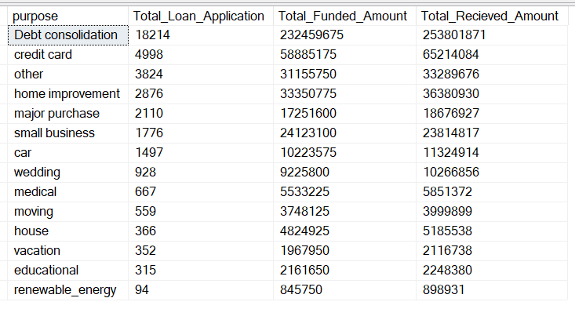

29.Home Ownership Analysis

SELECT

home_ownership,

COUNT(id) AS Total_Loan_Application,

SUM(loan_amount) AS Total_Funded_Amount,

SUM(total_payment) AS Total_Recieved_Amount

FROM Bank_data

GROUP BY home_ownership

ORDER BY COUNT(id) DESC

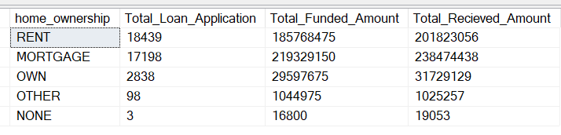

DAX Query:-

For all date in new table:-

Date Table = CALENDAR(MIN(Bank_data[issue_date]),MAX(Bank_data[issue_date]))